**Restaurant Management System for The Grill House Restaurant**

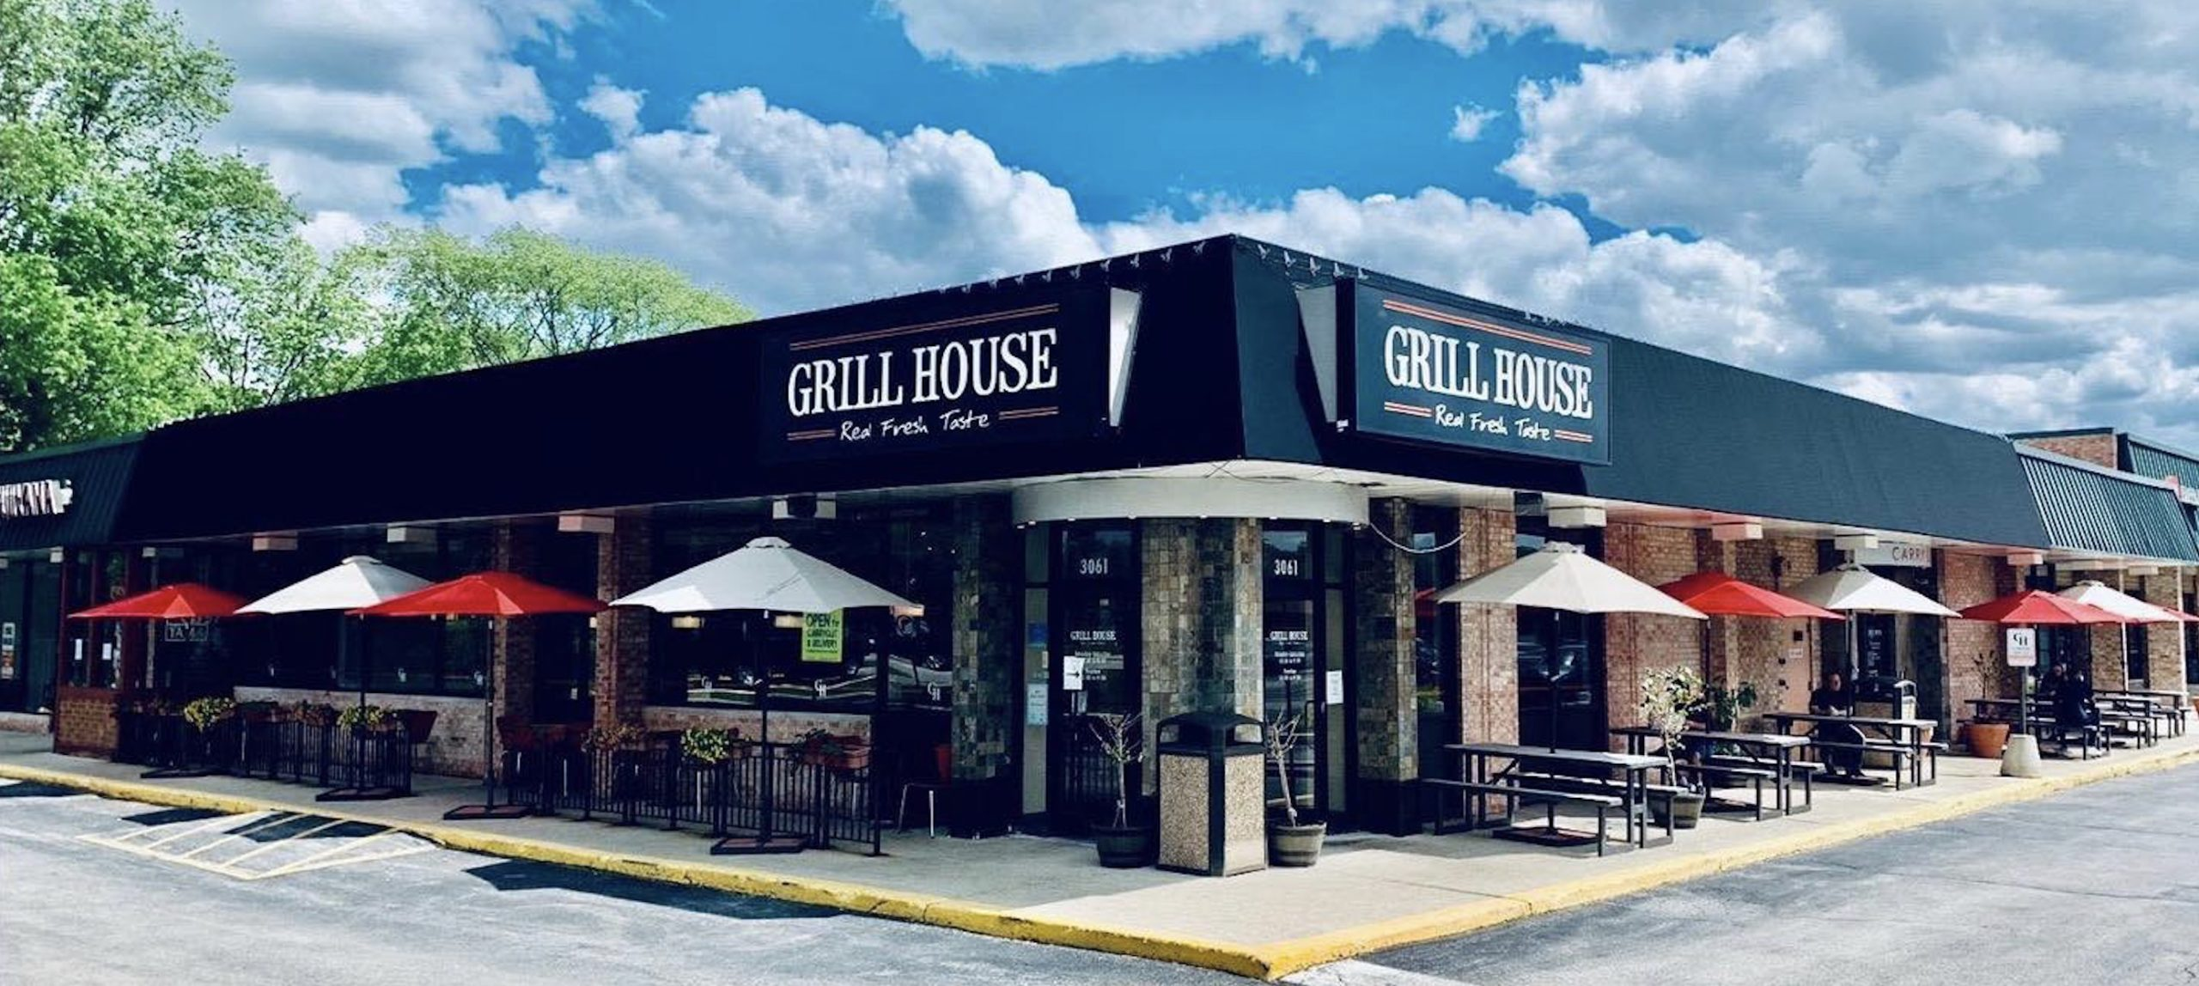

**Submitted by:**

Mohit Pal

Table of Contents

1- Introduction 3

1.1- Business Analysis Core Concept Model (BACCM) 3

1.2- Requirement Classification Schema (RCS) 4

2- Identify stakeholders 6

3- The proposed system workflow 7

4- The In-scope and Out of Scope Items for HMS 7

5- Finding the Scope of Restaurant Management System (HMS) (Context Diagram) 8

6- Main features of HMS 9

7- ER diagram of the system 10

8- How data will flow in HMS 11

9- Key functional and Non-functional requirements 12

10- Flow chart for the customer’s admission procedure 13

11- Wireframe for Home page and Customers registration 14

# 1- Introduction

A US celebrity chef James Oliver has his own chain of restaurants, The Grill House, across different cities in the USA. He wanted to put a new Restaurant Management System to track the day-to-day management of his restaurant.

Currently they have a paper-based system for the same and this has many issues. Currently the orders were taken by the waiters on paper and a paper-based bill was presented to the customers.

All the bills were entered into an excel sheet by the manager at EOD to know the total sales and item wise sales for the day. Then reports were generated on excel to know trends and details like daily, weekly, and monthly sales. Which dishes were popular and which weren’t doing so well?

Restaurants need a system that will allow them to easily update their menu. The clients currently do not have a system that recognizes the different types of users such as managers, waiters, etc. and they would like to be able to limit the access of some options of the system to certain users.

## 1.1- Business Analysis Core Concept Model (BACCM)

## 1.2- Requirement Classification Schema (RCS)

1. **Business Requirements:** To develop a Restaurant Management System (HMS) to manage all the restaurant operations which can help the customers to book online appointments and track their medical records.

* Reducing operating costs of the restaurant.
* Provides reports to senior management for decision-making.
* Save Customer time by keeping medical records stored in the cloud.
* Keeps track of Empty and occupied beds in the restaurant.
* Reduced paperwork and documentation in the restaurant.

1. **Stakeholder Requirements:** The key stakeholders are Customers, Restaurant staff, and management.

* **Customers:** Customers being the users of HMS should be able to book online appointments and able to access their medical records and get reminders for their appointments.
* **Restaurant staff and management:**
* **Doctors and nurses:** As the restaurant staff the doctors and nurses should be able to access the data in order to check medical history and suggest medication.
* **Registration and billing staff:** The registration staff should be able to use the system easily in order to register the customer and assist the billing team with bill processing.
* **Laboratory staff:** The laboratory staff should have access in order to track and provide reports for the prescribed tests of the customer assisting the doctor, customers, and billing team accordingly.
* **Senior Management:** The system is to be designed in a way that it provides appropriate reports to the senior management that assist in the decision-making process.

1. **Solution Requirements:**

* **Functional Requirements:**
* Customer registration and appointment management
* Appointment reminders
* Bed occupancy
* Billing assistance
* Laboratory, blood bank, and radiation department assistance and management
* Staff management
* Instructions for customers
* Insurance Details
* Reports for management decision making
* **Non Functional Requirements:**
* MYSQL database to be used since it is open source and free.
* The operating system should be Windows 2016
* The system should be and web-based application
* This system shall respond within 1 second
* The system shall keep all the logs for errors
* This system should be scalable to 500 users at a time
* The screen should be self-explanatory and user-friendly.

1. **Transition Requirement:** The users of this system should be trained enough to use it efficiently. As there will be reduced or no paperwork involved in the process every user should have access to the system through portable devices (Mobile, tablets, laptop, etc).

# 2- Identify stakeholders

RACI matrix is used here for identifying the responsibility of each stakeholder involved in the process:

Responsible (R): The individuals who will be performing the work on the task.

Accountable (A): The individual who is ultimately answerable for the completion of the task and is the decision maker.

Consulted (C): The stakeholder (group) who will be asked to provide opinion or information about the task.

Informed (I): The stakeholder (group) that is kept up to date on the task and its outcome.

|  |  |  |  |  |
| --- | --- | --- | --- | --- |
| **Stakeholders** | **Responsible** | **Accountable** | **Consulted** | **Informed** |
| Project Manager |  | A |  |  |
| Developer | R |  |  |  |
| Tester | R |  |  |  |
| Domain SME |  |  | C |  |
| Operational Support |  |  | C |  |
| Implementation SME | R |  |  |  |
| Business Analyst | R | A |  |  |
| Manager |  |  | C | I |
| Customers |  |  |  | I |
| CEO |  |  |  | I |
| Waiter |  |  | C |  |

# 3- The proposed system workflow

As-Is Process map:

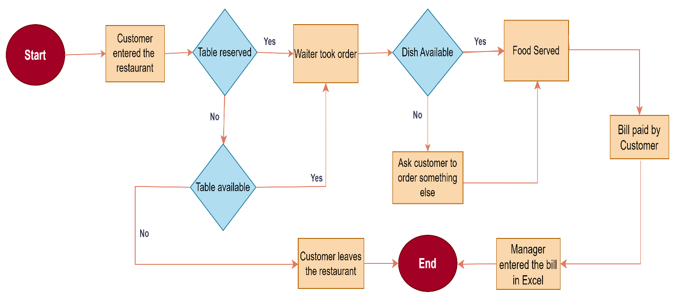

Future Process map:

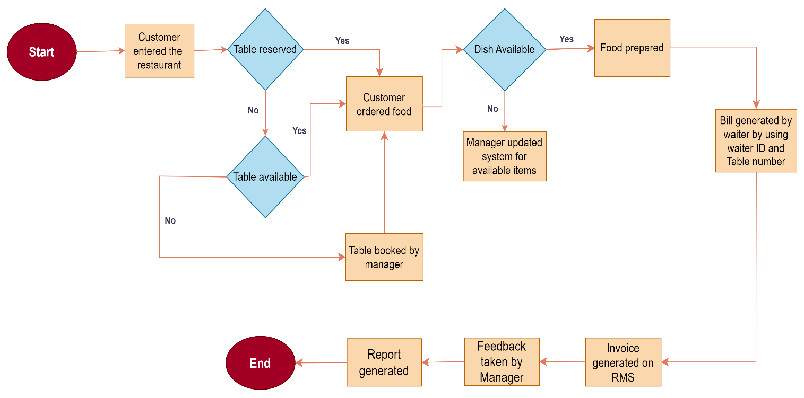

# 4- The In-scope and Out of Scope Items for HMS

|  |  |
| --- | --- |
| **In-Scope Requirements** | **Out-of-Scope Requirements** |
| Online appointment Scheduling | Only for registered users |
| Appointment Reminders | Appointment reminders only to existing Users |
| Customers Registration | Registration must be completed |
| Add / Update medical records | Only after consultation with the doctor |
| Medical prescriptions | Only after a doctor prescribed |
| Lab test results | Lab test results must be updated on HMS |
| Bed Occupancy | Should be more than no. of beds in the clinic |
| Restaurant staff management | Only Mayo Clinic staff management |
| Billing and Reports generation | Billing must be generated at the end |

# 5- Finding the Scope of Restaurant Management System (HMS) (Context Diagram)

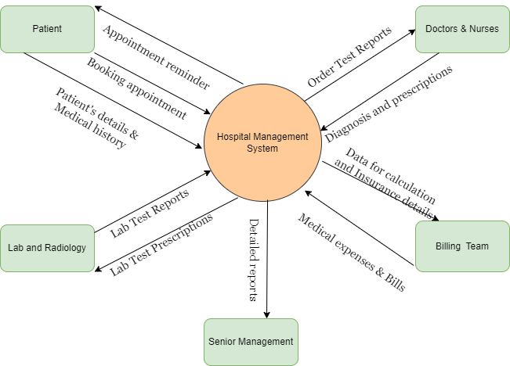

# 6- Main features of HMS

1. Web-based Management System

* Must have MYSQL database and operate with Windows 2016
* Must support a volume of at least 500 users at a time
* Must respond within 1 second
* Must be interactive and user-friendly
* Must be working all the times

1. Customer Registration and Login
2. Appointment reminders via Email or SMS
3. Schedule/ Reschedule/ cancel appointment
4. Store customer's medical records for anytime access
5. Staff allocation
6. Vacant and allocated bed details
7. Bill generation
8. Customer’s insurance details
9. Reports for Senior management

* Bed occupancy for each day
* Doctor’s appointment and revenue generation through OPDs
* Total number of OPD and admitted customers
* Which doctor generates the maximum revenue
* Total amount of earnings through OPDs and admitted customers
* Total amount of earnings through lab and radiology

# 7- ER diagram of the system

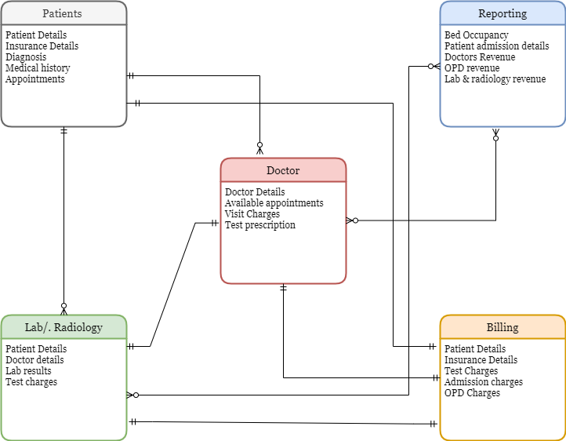

# 8- How data will flow in HMS

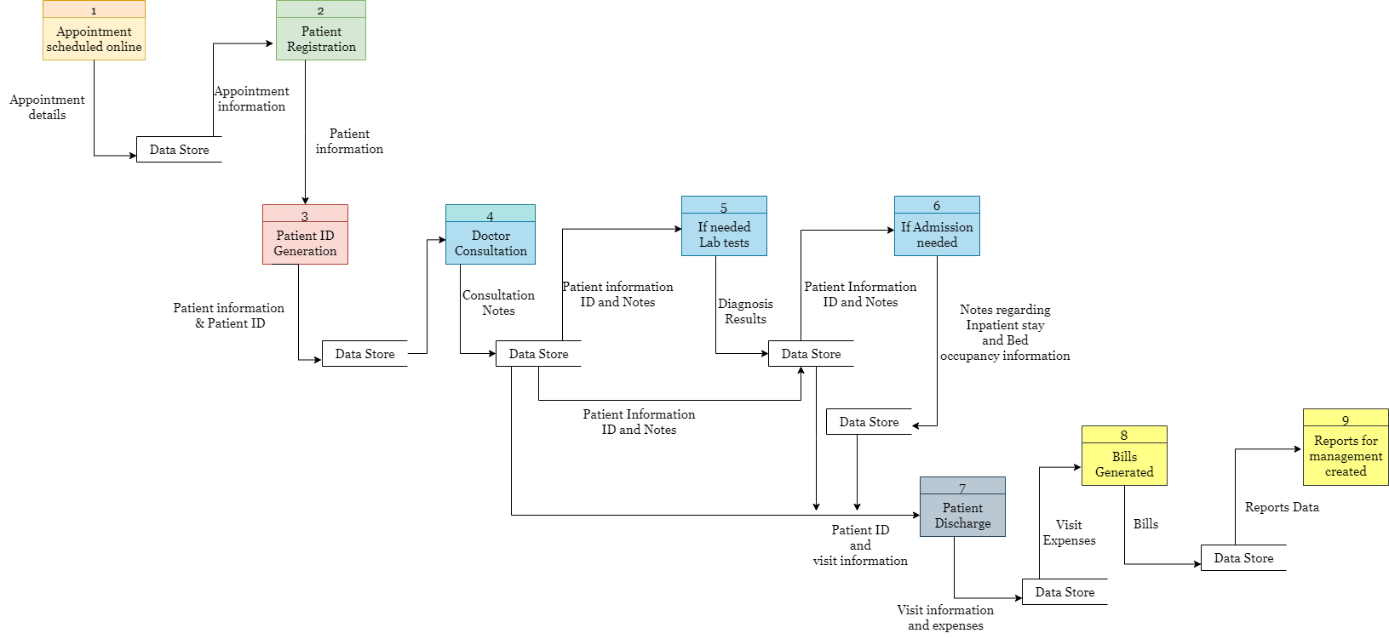

# 9- Key functional and Non-functional requirements

1. **Functional Requirements:**

* Customer registration screen
* Appointment booking and reminder
* Customer’s medical records
* Doctor’s prescription page
* Lab and radiology reports page
* Bed occupancy details portal
* Staff allocation and management
* Medical expenses and billing calculation
* Reports for senior management
* Insurance information

1. **Nonfunctional Requirements:**

* MySQL Databaseto be used since it is open source and free.
* The operating systemshall be Windows 2016
* The system shall be a web-based application.
* The system shall respond within 1 second
* The system must support 500 people using at a time
* The system shall keep logs of all the errors
* The system shall be available all the time
* The system should be self-explanatory and very user friendly.

# 10- Flow chart for the customer’s admission procedure

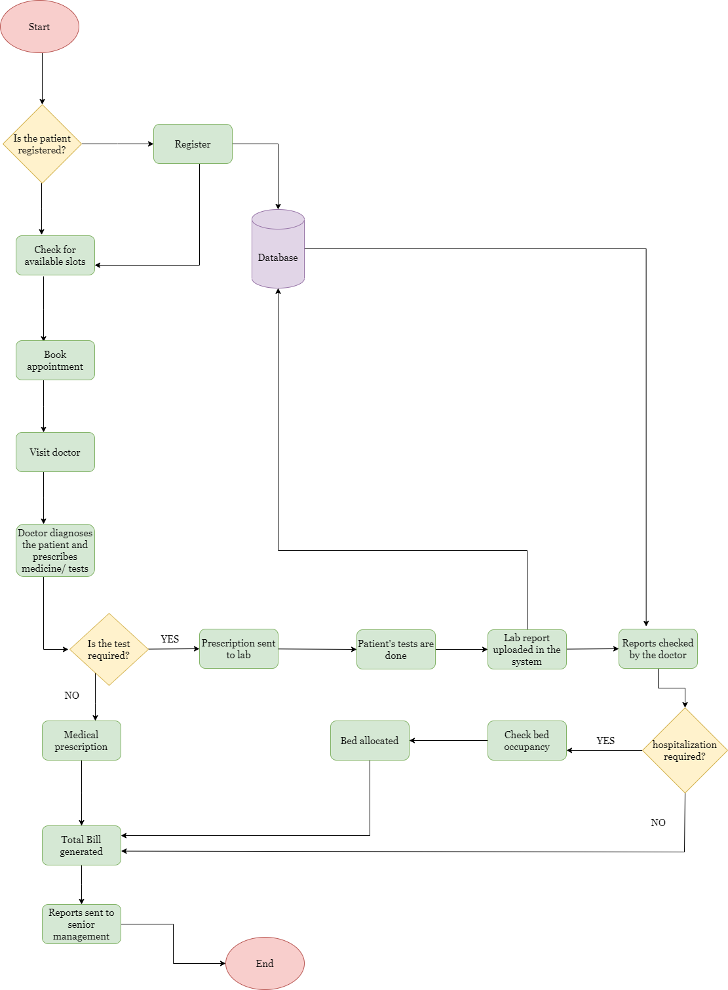

# 11- Wireframe for Home page and Customers registration

